The COST offices are situated in the southern part of Brussels (www.cost.eu) on the Avenue Louise. There are plenty of restaurants offering an international cuisine in the immediate vicinity such as Manhattn's Burgers, Makisu Sushi restaurant, Rouge Tomate, Le Chou de Bruxelles, Foodminute, XIX Ieme, …
For a more informed decision, we refer to the following interactive link https://goo.gl/fBNwwJ
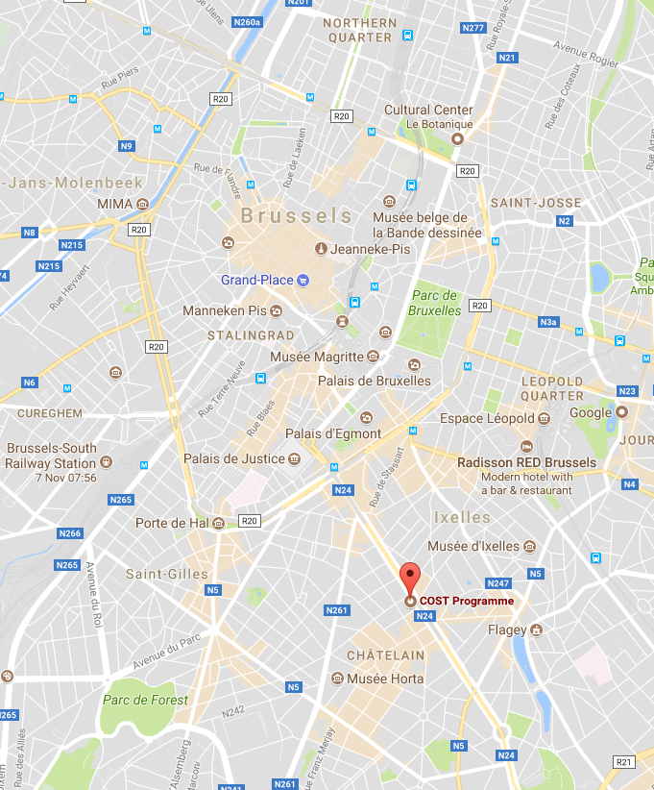 | 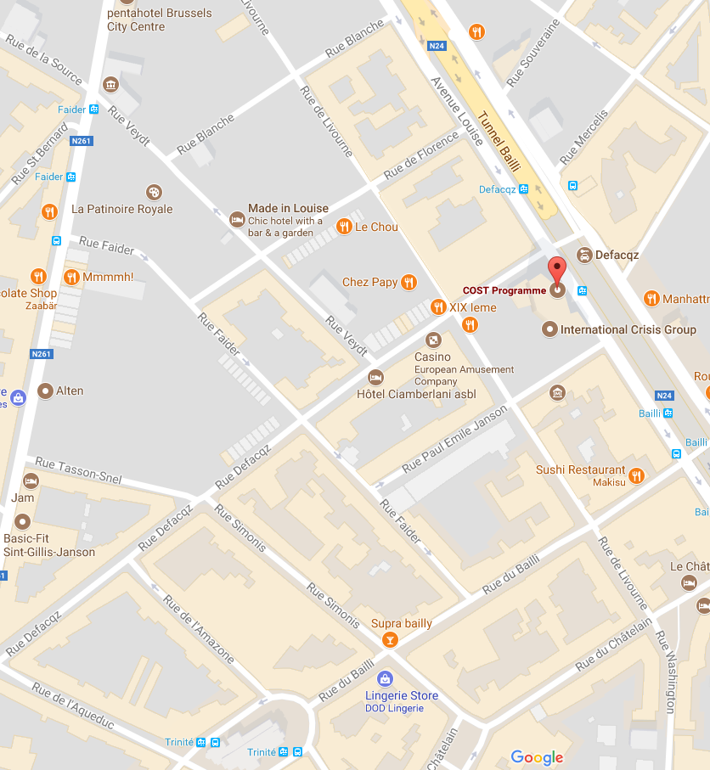
Location of the COST offices in Brussels (left); detail of the Avenue Louise area with indication of local restaurants.

The centre of Brussels which offers hundreds of restaurants in all price classes is easily reached by public transport. Tram 93 and 94 take you from the COST offices to the centre in ~15 minutes.

